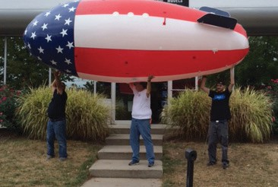

The Northern Virginia Radio Control Club & Woodson High School Junior Class
RC AUCTION

Sunday, Oct 25, 2015
WT WOODSON HIGH SCHOOL 9525 MAIN ST, FAIRFAX
Directly across from Fair City Mall on VA Route 236 Auction in Auxiliary Gym (2nd Gym) – Use Entrance #3 Look For Signs
Setup and Viewing 8-10 a.m. – Auction 10 a.m. R/C Airplanes, Helicopters, Cars, Boats, Supplies

- Buy and/or Sell
- Auction Tags Provided
- Fixed-Price Tables Available
- Admission and Door Prize Entry- $5
- $20 Auction Minimum
- Fixed Price Table No Minimum
- 10% of Sale Proceeds to Club
- Computerized Accounting
- Credit Cards Accepted
- NO PRIVATE SALES
- Food and Drink Available
For more information, contact Bob Freas (703) 395-9503 More details available on our webpage www.1nvrc.com

