October 18, 2018 NVRC Meeting Minutes:
Provided by John Roach and Carl Hampton

Visitors and new members – None, but 19 members attended and Kenny reported that 16 pilots competed in the Fun Fly held 6 October.

Mark Franke kicked off the meeting at 7:40 pm with a photo of a possible group buy for only $120,000. It is a B-26 in serious need of restoration. His mystery photo was a Walrus, a British WWII amphibious rescue aircraft. It was this type of aircraft that fished Stephen Ananian out of the English Channel after he was forced to ditch a flak-damaged P-51on his first mission with the 339 FG. Mark called for volunteers to help with the 20 October auction. It will include RC donations from two estates - about 5 carloads of airplanes.

Dues Increase – A full presentation on a possible dues increase of $10 will be made at the next regular meeting.

Holiday Party – 1 December 2018.

Lorton VP Report – Mark thanked those volunteers who have been mowing Lorton. He handed off a generator and string trimmer to Roger Barker to place in the shed at Lorton. Mark asked for a volunteer to manage Lorton field in the upcoming year as he is unable to do so.

Poplar Ford Report – John Roach requested we report any contractor vehicles driving thru the airfield to access the park. Their vehicles left large ruts in the parking lot, spectator area and west approach. This was brought to the attention of FCPA staff. Controlled burns are planned for most tall grass areas adjacent to the airfield within the next few months.

2019 Slate of Officers – The current Board members have volunteered to stay on for 2019: Jonathan Pruett, President; John Roach, Vice President; Carl Hampton, Secretary (if he does not move); Paul Lukas and Tung Phung, Members at Large. Paul Lukas pointed out that the ban on FPV racing effectively killed young member recruitment. He suggested FPV racing at Mickey Gordon Park in Middleburg might revive interest in NVRC.
There were no officer nominations from the floor.

Float Fly at Lake Fairfax Park – Tony Claridge pointed out that Fairfax County now permits drones to fly in all Fairfax County parks that are 15 or more nautical miles from Reagan National Airport. He speculated that it may be possible to schedule a float fun fly at Lake Fairfax. Mark Franke replied that he would inquire about this with FCPA if Tony prepared a reasonable event proposal. The state law forcing Fairfax County to allow drones to fly in its parks expires in a year.

Lorton Hours Expansion – Al Norcott asked if it was possible to expand the flying hours at Lorton. Our present agreement with Fairfax County has been in effect for nearly three years and is renewed at 3 year intervals. It is appropriate to discuss this possibility with the county at this time, but we need to be patient with the county during any such discussion. Any change in our agreement subjects the entire agreement to possible revision.

Show N Tell – Roger Barker showed slides of his visit to the Virginia Beach aviation hanger. It is a private collection of WWI and WWII aircraft put together by Jerry Yeager. It is worth a road trip to see it.

Paul Lukas showed video of his road trip to the RC FPV Festival in Covington, VA. The two day event involved two days of flying with RV camping, mud, rain and showers at the local YMCA. A good time was had by all who attended. The flying wing racers were all of the same type, motor and battery size. Winning was a matter of pilot skill, luck and battery brand. The best battery brand appeared to be “Jet Fuel.”

ARF Quality Decline – Tony Claridge shared that his V900 ARF would not start. He found that it had many manufacturing defects that forced him to carefully troubleshoot and check linkages and wiring before he could get it to work. He stated that this may be the trend in new planes. He and others have observed a recent decline in ARF manufacturing quality control. His suggestion was to check everything. “There is no such thing as an ARF…It ain’t what it used to be.” Mark agreed and chimed in that he had even found poorly molded clevis links.

3D Printed Parts – Paul Lukas showed a number of PT-17 parts he made with his new 3D printer using 3D Lab Print plans. The 3D plans available online include those for F-86, Mig-15, Spitfire, Corsair, BF-109, P-38, F-15, and Piper Pawnee. The precision fit of the parts was remarkable.

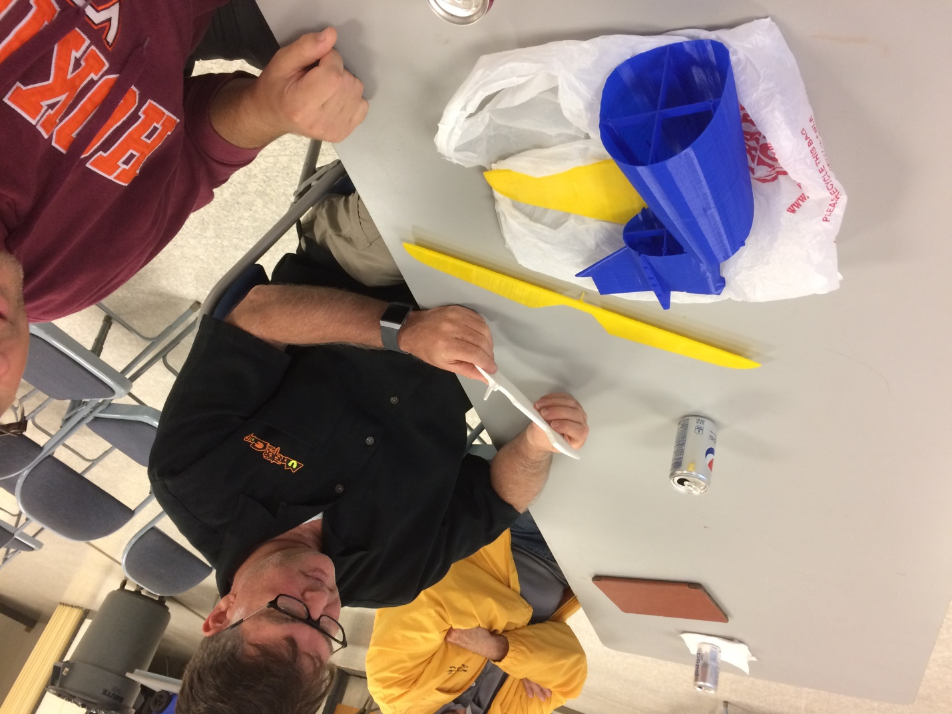

This was clearly evident in the internal bracing of the fuselage segments and the way everything fit together as well as the dummy radial engine that Paul printed from the plans.

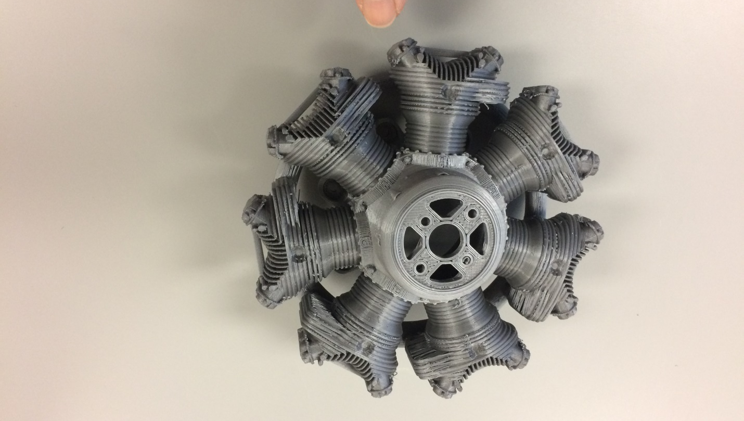

Acuity Pattern Plane - Terry Terrenoire showed us his Andrew Jesky- designed Acuity ARF. The $850 kit included the aircraft, ESC, motor, and wing covers. Quality of the kit was superb. He said it flies as if on rails.

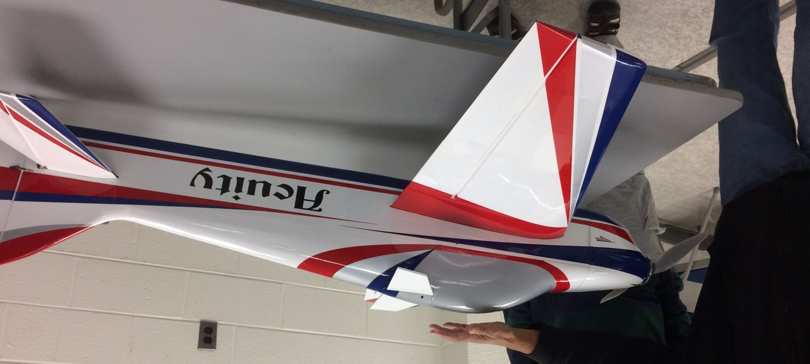

Roger Barker won the $20 Hobby Hanger Show N Tell gift card. The 50:50 paid out $13 to John Roach. Snack donations were $27.

